DESIGN AND CONSTRUCTION OF A LABORATORY REPORT SUBMISSION SYSTEM

BY
Abdurrahman Sheriff
190403022

THE DEPARTMENT OF ELECTRICAL AND ELECTRONICS ENGINEERING
UNIVERSITY OF LAGOS

SUPERVISED BY
Dr. (Mrs.) F. Olobaniyi

APRIL, 2026

CERTIFICATION

This is to certify that this project was carried out by SHERIFF, Abdurrahman with the matriculation number 190403022 in the Department of Electrical and Electronics Engineering, Faculty of Engineering, University of Lagos under the supervision of Dr. (Mrs.) F. Olobaniyi.

– – – – – – – – – – – –– – –– – – – – – – – – – –

Abdurrahman Sheriff Date

Author

– – – – – – – – – – – – – – – – – – – – – – – – – –

Dr. (Mrs.) F. Olobaniyi Date

Supervisor

– – – – – – – – – – – – – – – – – – – – – – – – – –

Prof. Peter Oluseyi (H.O.D) Date

ACKNOWLEDGEMENT
I would like to express my profound gratitude to my project supervisor, Dr. Olabaniyi, for her invaluable guidance, patience, and continuous support throughout the duration of this project. My sincere appreciation goes to the Head of Department, Prof. Peter Oluseyi, the Project Coordinator, [Name], and all the academic and non-academic staff of the Department of Electrical and Electronics Engineering at the University of Lagos. Finally, I am deeply thankful to my family and friends for their unwavering encouragement.

ABSTRACT
Laboratory practicals are a vital part of engineering education, but the traditional way of handling lab reports is outdated and stressful. Relying on physical paper leads to lost documents, extremely slow feedback for students, and an exhausting amount of manual work for lecturers who have to grade hundreds of papers by hand. This project focuses on building a simple, easy-to-use Web-Based Lab Report Submission System specifically designed for the Department of Electrical and Electronics Engineering. The goal is to replace the chaotic paper system with a clean digital platform. The app is built with a React frontend to make it fast and responsive, a Node.js backend to handle heavy traffic, and a secure PostgreSQL database to store files safely. By using this system, students get instant digital receipts for their work and can track their grades in real-time, while lecturers get a dedicated dashboard that makes grading faster and removes the fear of losing student work. Ultimately, this project modernizes how the department handles student assessments.

TABLE OF CONTENTS
FRONT PAGE ................................................................................................................................ i CERTIFICATION ......................................................................................................................... ii ACKNOWLEDGEMENT ............................................................................................................ iii ABSTRACT ................................................................................................................................. iv TABLE LISTING .......................................................................................................................... v FIGURE LISTING ....................................................................................................................... vi
LIST OF ABBREVIATIONS ..................................................................................................... vii
CHAPTER 1 : INTRODUCTION .............................................................................................. 1 1.1 Problem Statement ................................................................................................................... 2
1.2 Project Aim .............................................................................................................................. 2
1.3 Project Objectives .................................................................................................................... 3
1.4 Scope or Limitation of Project ................................................................................................. 3
1.5 Report Outline .......................................................................................................................... 3
CHAPTER 2 : LITERATURE REVIEW ....................................................................................................................................... 4 2.1 The Evolution of Academic Document Management ............................................................. 4
2.2 The Traditional Paper-Based Laboratory Workflow ............................................................... 5
2.3 Operational Inefficiencies of Physical Submissions ................................................................ 5
2.3.1 Vulnerabilities for the Student .............................................................................................. 6
2.3.2 The Exhausting Workload for Faculty .................................................................................. 6
2.3.3 The Problem of Physical Storage .......................................................................................... 7
2.4 Review of Existing Digital Submission Technologies ............................................................ 7
2.4.1 Moodle: Too Many Features, Too Much Confusion ............................................................ 7
2.4.2 Google Classroom: Too Simple for Universities .................................................................. 8
2.5 The Role of User Experience (UX) in Educational Technology ............................................. 8
2.6 Identification of the Research Gap .......................................................................................... 9
CHAPTER 3 : METHODOLOGY AND SYSTEM DESIGN ............................................... 10 3.1 Software Development Methodology .................................................................................... 10
3.2 Proposed System Architecture ............................................................................................... 11
3.2.1 The Frontend (What the User Sees) .................................................................................... 11
3.2.2 The Backend (The Brain of the App) ................................................................................. 11
3.2.3 The Database (The Secure Vault) ....................................................................................... 12
3.3 Requirements Analysis .......................................................................................................... 12
3.4 System Modeling ................................................................................................................... 13
3.5 Database Design and Schema Specification .......................................................................... 14
3.6 User Interface (UI) Design Principles .................................................................................... 16
REFERENCES ........................................................................................................................... 17

FIGURE LISTING
Figure 3.1: High-Level Three-Tier System Architecture
Figure 3.2: System Use Case Diagram
Figure 3.3: Database Entity-Relationship (ER) Diagram

LIST OF ABBREVIATIONS
- API: Application Programming Interface
- DOM: Document Object Model
- LMS: Learning Management System
- PDF: Portable Document Format
- RBAC: Role-Based Access Control
- UI/UX: User Interface / User Experience

CHAPTER ONE

INTRODUCTION
1.0 Introduction Laboratory practicals are one of the most important parts of any engineering education. In a classroom, students only learn the theory—like how electricity flows through a circuit or how communication networks send signals. However, it is inside the laboratory where they actually get to touch the equipment, wire the circuits, and see those theories happen in real life.
Doing the experiment is only half the work. The other half is proving that you understood what you did. This is why the laboratory report exists [1]. The report is the final product of the student's hard work. It forces them to organize their data, draw graphs, explain their mistakes, and show their final results. Research shows that learning how to write these scientific reports properly is a critical skill for future engineers, and students need fast, clear feedback from their teachers to actually improve [7].
For decades, the way universities handle these reports has not changed. The entire system is built on physical paper. Students write or type their reports, print them out, and physically carry them to the department to submit them. While this worked fine when classes were small, it is breaking down today. As more and more students enroll in engineering programs, the sheer amount of paper being passed around has become impossible to manage. Relying on physical paper is slow, stressful, and outdated.
This project is focused on fixing that exact problem. It details the building of a simple, modern Web-Based Lab Report Submission System. By moving this entire process online, we can completely remove the stress of paper documents and make life significantly easier for both the students doing the work and the lecturers grading it.
1.1 Statement of the Problem Sticking to a paper-based system creates a deeply frustrating experience for everyone involved. We can look at this problem from two sides: the student's side and the lecturer's side.
From the student's side, handing in a physical paper feels very risky. When a student finishes a hard lab report, they walk into a crowded department office and drop their paper into a pile or hand it to an assistant. At that moment, they have no receipt. If that piece of paper gets lost, pushed off a desk, or damaged, the student has no way to prove they ever submitted it. Furthermore, studies show that there is often a disconnect between what students think they should write in a lab report and what the lecturer actually expects [8]. When feedback is delayed for weeks because the lecturer is busy marking physical papers, the student cannot learn from their mistakes in time for the next lab.
From the lecturer's side, the problem is just as overwhelming. Imagine a lecturer teaching a course with three hundred students. Every week, they are handed three hundred physical folders. They have to carry these heavy stacks of paper to their office, manually sort them to make sure no one is missing, and find a safe place to store them. When it is time to grade, they have to physically flip through every page with a red pen. After hours of grading, their job still is not done. They now have to look at the score on the paper and manually type it into an Excel spreadsheet on their computer. This double-work is tiring, and it is very easy to accidentally type a "5" instead of an "8" when you are exhausted [2]. Finally, the department has to keep all these old papers for years just in case there is an audit, which takes up entire rooms of physical office space. The current system simply cannot keep up with modern education.
1.2 Project Aim The main goal of this project is to build a dedicated, easy-to-use web application that completely handles the submission, tracking, and grading of lab reports for large university classes.
1.3 Project Objectives To achieve this main goal, the project is broken down into five specific objectives:
- Design a clean interface: The system must be so simple that a student can upload their work in three clicks, and a lecturer can grade it without having to learn complex software.
- Build a secure login system: The app must recognize who is logging in. It must show students only their own work, while giving lecturers the power to see everyone’s work and enter grades.
- Create a reliable upload feature: The system must allow students to upload their reports smoothly, but it will strictly only accept PDF files so that formatting never gets messed up when the lecturer opens it.
- Set up a cloud database: The system must securely store all the PDF files and the final grades online. This completely removes the need for filing cabinets and physical storage.
- Build a real-time dashboard: The app must give students a screen where they can instantly see a "Submitted" receipt and watch their status change from "Pending" to "Graded."
1.4 Scope or Limitation of Project To make sure this software is built perfectly within the given timeframe, we have to draw strict boundaries around what it will and will not do.
This project is focused purely on solving the document management problem. It will successfully handle user logins, file uploads, grading inputs, and status tracking. It is built as a web application, meaning users will access it through a browser like Chrome or Safari on their laptops or phones.
However, to keep the prototype fast and reliable, some complex features are left out. It will not be a standalone mobile app that you have to download from the iOS or Android app stores. Additionally, it will not include automated AI features to check for plagiarism, and it will not automatically test coding assignments. It is strictly a platform for securely moving documents between students and lecturers.
1.5 Report Outline This project report is organized to guide the reader step-by-step through the problem and the solution. Chapter 1 introduces the core frustrations with paper reports and outlines what the project aims to do. Chapter 2 looks back at how universities have tried to manage documents in the past, explaining why current massive software platforms are still too confusing to use. Chapter 3 dives into how the new software is actually built, breaking down the specific technologies used to create the screens, logic, and database.

CHAPTER TWO
LITERATURE REVIEW
2.0 Introduction This chapter looks back at how universities have historically managed student documents, specifically tracking how the laboratory report has evolved from a physical piece of paper into a digital file. By closely examining the frustrations caused by the old paper methods, and by looking at why current software like Moodle or Google Classroom still leaves people frustrated, this chapter clearly explains exactly why a custom-built lab report system is so desperately needed.
2.1 The Evolution of Academic Document Management Laboratory practicals are a mandatory part of engineering and science degrees. For decades, the way we handled the assessments for these practicals was dictated entirely by the physical limits of paper. Students would run their experiments, write down their data in notebooks, and then type up a formal report. They would print these reports out, staple them, and hand them in before a strict deadline.
In the past, when university class sizes were small, this system worked perfectly fine. A lecturer might only have twenty students, making it easy to collect, read, and grade the papers. However, as universities have grown, the number of engineering students has skyrocketed. What used to be a manageable stack of twenty papers is now a mountain of three hundred papers per class [3]. Recently, there has been a massive shift toward digital and online lab experiences in higher education, which has completely exposed how outdated and broken physical paper submissions truly are [9].
2.2 The Traditional Paper-Based Laboratory Workflow To understand why we need new software, we have to look at how painful the current paper workflow is. Today, the standard rule is that students must physically transport their printed reports to a designated department office or hand them directly to a laboratory technologist. Sometimes, they use pre-printed lab manuals where they just fill in the blanks with a pen. Once that paper leaves the student's hand, it enters a chaotic physical system that is highly vulnerable to mistakes.
2.3 Operational Inefficiencies of Physical Submissions Relying on physical paper creates a stressful and compromised experience for everyone involved in the university.
2.3.1 Vulnerabilities for the Student When a student drops their paper in a submission box, they do not get a receipt. The process is completely blind. If that document is accidentally misplaced, mixed into the wrong folder, or damaged, the student is the one who suffers. They have no way to prove they ever submitted it.
Furthermore, waiting for a physical paper to be graded takes weeks. Research shows that learning how to write scientific reports properly is hard, and students often misunderstand what the lecturer actually wants to see [8]. Because it takes so long for the lecturer to grade the physical papers and hand them back, the student does not get their feedback in time. They end up making the exact same mistakes on their next lab report because they were kept in the dark about their previous score.
2.3.2 The Exhausting Workload for Faculty For the lecturers and laboratory assistants, managing paper is an exercise in pure frustration. A lecturer teaching a large course spends hours just doing manual labor—collecting the papers, sorting them by matriculation number, and finding a safe, dry place to store them. This is time that should be spent teaching or researching.
When it comes time to actually grade, the process is exhausting. Grading physical scripts requires a massive amount of mental energy. Once the lecturer writes the score on the paper with a red pen, their job still is not done. They now have to sit at a computer, look at the paper, and manually type that score into an Excel spreadsheet. This double-work is notorious for causing human error. It is incredibly easy for a tired lecturer to accidentally type a "5" instead of an "8," which unfairly damages a student's grade [4].
2.3.3 The Problem of Physical Storage Finally, keeping all these papers creates a real estate problem for the department. Universities are often required to keep student assessments for several years just in case there is an audit or a grade dispute. Storing thousands of lab reports requires giant filing cabinets that eat up valuable office space. Trying to dig through those cabinets to find one specific paper from three years ago is a nightmare.
2.4 Review of Existing Digital Submission Technologies To try and fix this paper problem, many universities have bought massive, expensive Learning Management Systems (LMS). However, researchers analyzing lab submission systems at major universities have found that schools still struggle to find software that perfectly balances ease-of-use with the specific technical needs of a lab environment [10].
2.4.1 Moodle: Too Many Features, Too Much Confusion Moodle is one of the most popular platforms in the world. It can do almost anything—it has discussion boards, complex quizzes, peer-review systems, and calendars. But because it tries to do everything, it is incredibly confusing to use.
For the simple task of submitting and grading a PDF lab report, Moodle is overkill. The screens are cluttered with unnecessary buttons. A lecturer often has to click through four or five different menus just to download a batch of student PDFs. This creates what designers call "cognitive load"—meaning the software makes you think too hard just to do a simple task [5]. Because it is so frustrating to navigate, many lecturers simply refuse to use it and go back to paper.
2.4.2 Google Classroom: Too Simple for Universities On the other end of the spectrum is Google Classroom. It is very easy to use and looks great. However, it is fundamentally just a digital drop-box. It simply takes a student's file and dumps it into a Google Drive folder. It does not have the powerful, organized database structure that a university department needs to track thousands of matriculation numbers, manage different lecturer permissions, and securely archive grades for years.
2.5 The Role of User Experience (UX) in Educational Technology If software is hard to use, people will not use it. It is that simple. Studies show that when students and instructors are given clean, dedicated digital systems that are actually designed well, their overall satisfaction and trust in the grading process goes up significantly [11]. A successful submission system must be designed around a smooth, frictionless journey. Big, clear buttons for uploading. A clean, single-screen dashboard for lecturers to type in grades. These aren't just pretty design choices; they are absolute necessities to make sure the department actually adopts the software.
2.6 Identification of the Research Gap Right now, departments are stuck between two bad choices. They can either use the chaotic, easily-lost physical paper method, or they can use bloated, confusing software like Moodle that frustrates the lecturers. There is a massive gap in the market for a lightweight, custom-built platform that does one thing perfectly: collect lab reports, allow lecturers to grade them easily, and show students their scores instantly.
2.7 Chapter Summary This chapter has established the historical reliance on physical document management within academic laboratories and detailed the severe logistical inefficiencies it causes. While digital LMS platforms like Moodle and Google Classroom offer alternatives, their generalized architectures and steep cognitive loads make them suboptimal for dedicated departmental use. The literature unequivocally supports the necessity of developing a specialized, user-centric Web-Based Lab Report Submission System to bridge this operational gap.

CHAPTER THREE
METHODOLOGY AND SYSTEM DESIGN
3.0 Introduction This chapter serves as the blueprint for the software. It breaks down exactly how the new Lab Report Submission System is built. It covers the strategy used to build it without crashing, the specific modern technologies chosen for the code, and how the database is structured to securely hold all the student records.
3.1 Software Development Methodology When building complex software, you cannot just start typing code and hope it works at the end. For this project, the Agile Software Development Methodology was used [6].
Think of Agile like building a house room by room, rather than trying to build the whole house at once. Instead of waiting until the very end to test the software, Agile breaks the work into small, testable chunks. First, we built the login screen and tested it to make sure passwords were secure. Once that was perfect, we built the PDF upload feature and tested it to make sure it could handle large files. By building and testing in small steps, we ensure that the core features are rock-solid. This guarantees that when hundreds of students all try to upload their reports five minutes before the deadline, the system will not crash.
3.2 Proposed System Architecture The application is built using a modern Three-Tier Architecture. This simply means the software is split into three separate layers that talk to each other. This keeps the code organized and makes the app run incredibly fast.
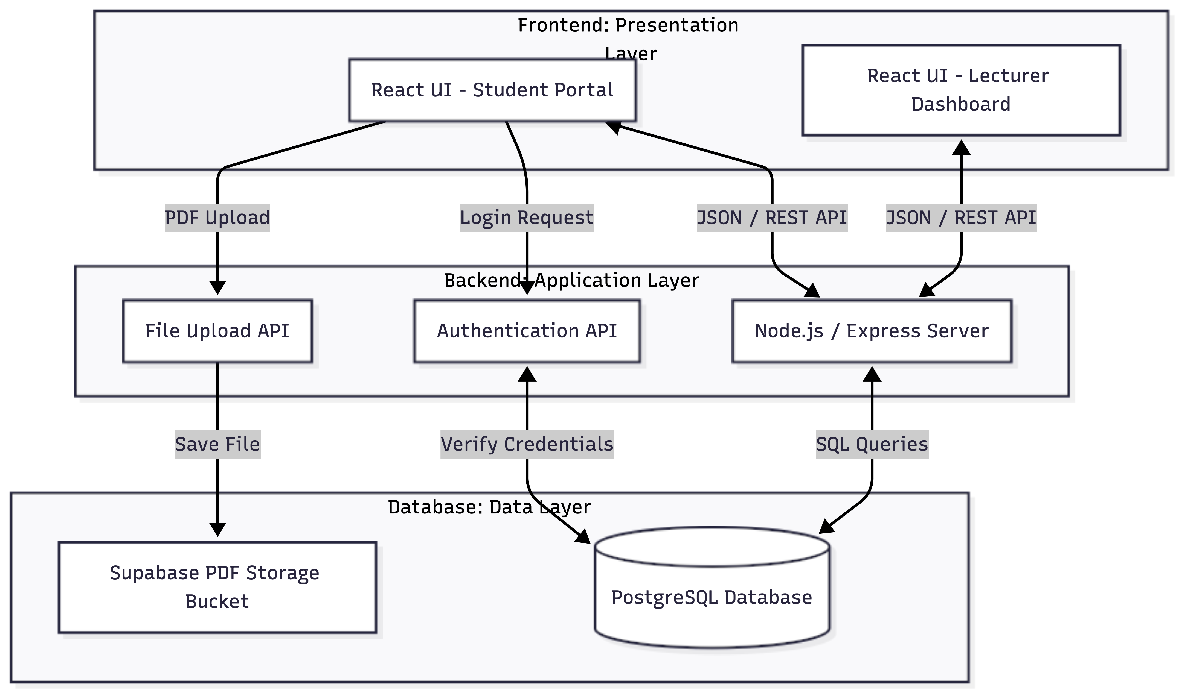
Figure 3.1: High-Level Three-Tier System Architecture
3.2.1 The Frontend (What the User Sees) The top layer is the Presentation Layer. This is the actual website the students and lecturers interact with. It is built using React, a highly popular tool created by Facebook. We chose React because it makes websites feel like incredibly fast mobile apps. When a lecturer clicks "Save Grade," React updates the screen instantly without forcing the entire web page to reload and flash white. It provides a smooth, frictionless experience.
3.2.2 The Backend (The Brain of the App) The middle layer is the Application Layer. This is the invisible engine room of the software, and it is built using Node.js. When a student clicks "Upload," the frontend hands the file to Node.js. Node.js is famous for being able to juggle hundreds of tasks at the exact same time without slowing down. It takes the file, checks to make sure the student isn't trying to upload a virus, and safely passes it to the database. It also acts as the security guard, checking everyone's login tokens to ensure a student can never accidentally see another student's grades or access the lecturer's dashboard.
3.2.3 The Database (The Secure Vault) The bottom layer is the Data Layer. This is where all the actual information lives permanently. For this project, we are using PostgreSQL, hosted on a platform called Supabase. Supabase acts as a highly secure vault. It does three major things:
- It handles the login system, locking away user passwords securely.
- It provides a "Storage Bucket"—a digital warehouse designed specifically to hold the heavy PDF files that students upload.
- It provides the organized tables where we store the names, matriculation numbers, and final numerical grades.
3.3 Requirements Analysis Before writing any code, we had to define the absolute "must-haves" for the system.
Functional Requirements (What it must do):
- The system must allow users to log in securely and immediately identify if they are a Student or a Lecturer.
- The system must allow students to upload files, but it will strictly reject anything that is not a PDF (to prevent lecturers from having to open weird file formats).
- The system must give lecturers a private dashboard to see all uploaded PDFs and type in a score.
- The system must instantly update the student's screen the second the lecturer saves the grade.
3.4 System Modeling: How the App is Actually Used To ensure the software is easy to use, we mapped out the exact step-by-step journey for both types of users.
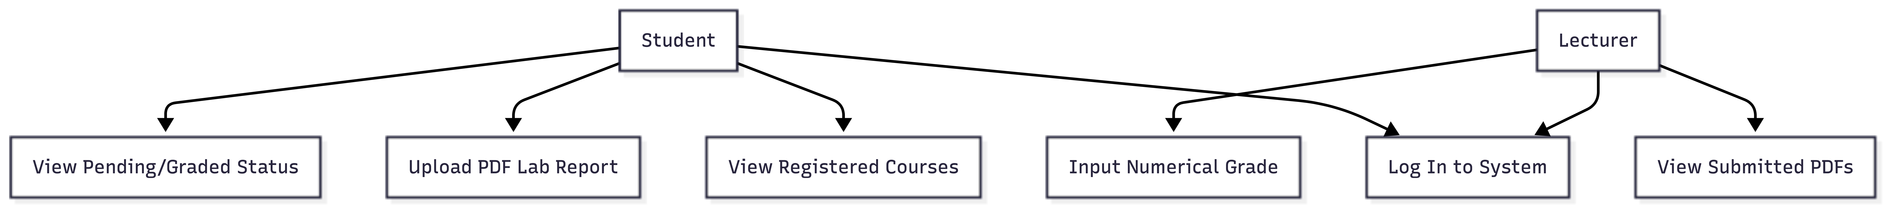
Figure 3.2: System Use Case Diagram

The Student's Journey:
- The student opens the website on their phone or laptop and logs in with their matriculation number.
- The system recognizes them as a student and takes them to their personal dashboard.
- They click on the specific class they are taking (e.g., EEG 401).
- They click the large "Upload" button and select their PDF report.
- The system saves the file to the Supabase vault and immediately changes the status on their screen to a comforting green "Pending Evaluation" badge. They now have a digital receipt.
The Lecturer's Journey:
- The lecturer logs in. The system recognizes their staff ID and unlocks the private Grading Dashboard.
- The dashboard shows them a neat, organized list of every student who has submitted a report.
- The lecturer clicks on a student's name, opens the PDF right there in the browser, reads it, and types a score into the box next to it.
- They click "Save." The system instantly updates the database, changes the status to "Graded," and moves the lecturer to the next student in line.
3.5 Database Design To keep the application running at lightning speed, the PostgreSQL database is highly organized into three main lists, called tables.
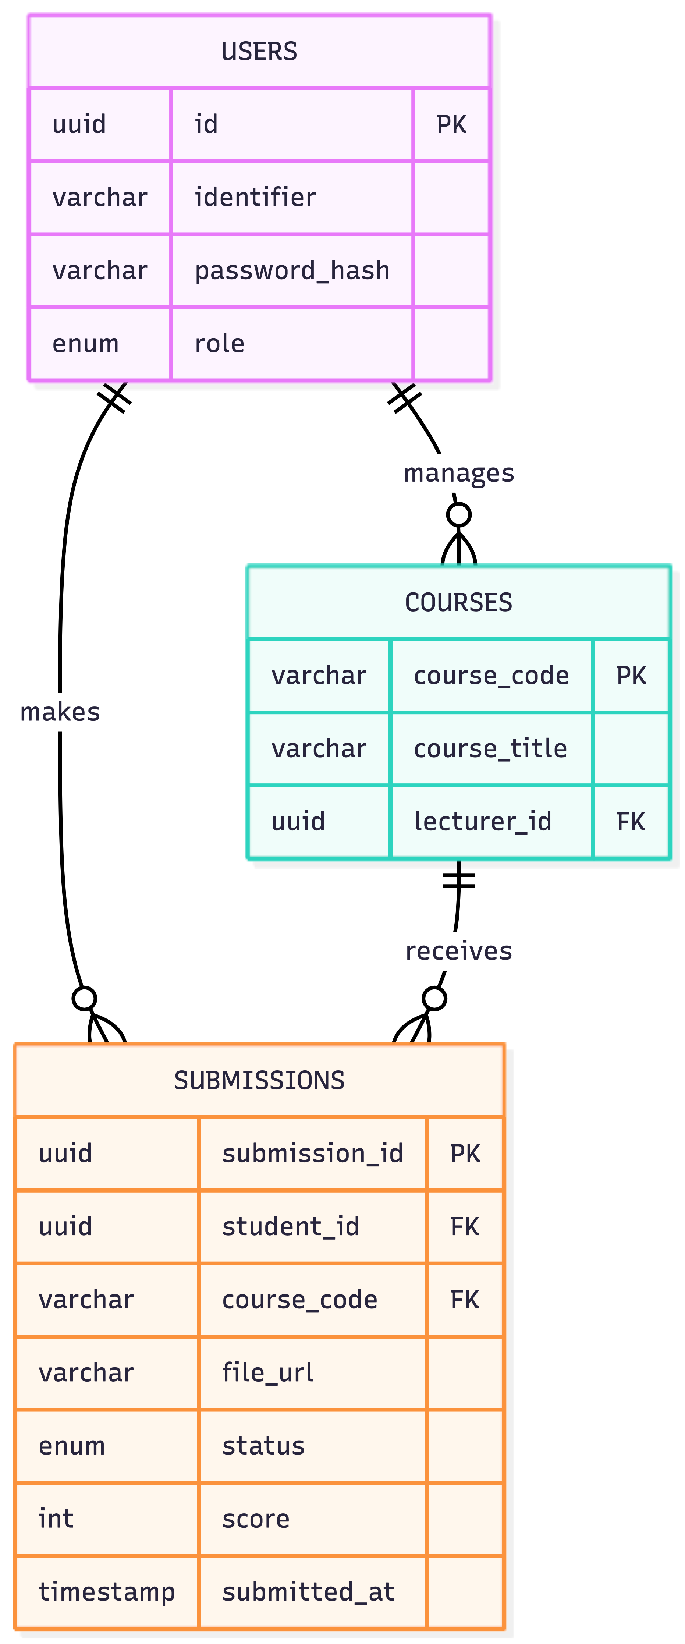
Figure 3.3: Database Entity-Relationship (ER) Diagram
1. The Users Table: This keeps track of who is allowed in the building. It stores the user's ID, their securely scrambled password, and a label marking them as either a 'Student' or 'Lecturer'.
2. The Courses Table: This is a simple directory of the engineering classes being taught, like "EEG 401: Power Systems Lab."
3. The Submissions Table: This is the most important part of the database. It acts as the digital connective tissue. It links a specific Student to a specific Course, stores the secret internet link to where their PDF is saved in the vault, holds their final numerical grade, and records the exact minute and second they uploaded it so there are no arguments about late submissions.
3.6 User Interface (UI) Design Principles Because bad design ruins good code, the actual screens were designed to be as minimalist as possible. We used large, highly visible typography so that tired lecturers don't have to squint. Buttons are clearly labeled (e.g., a massive blue "Upload Report" button) so that students do not have to guess what to do next. Finally, the entire website is "responsive," meaning it shrinks and rearranges itself perfectly whether it is being viewed on a massive desktop monitor in a lecturer's office or on a student's mobile phone while they are riding the bus.

REFERENCES
[1] L. D. Feisel and A. J. Rosa, "The role of the laboratory in undergraduate engineering education," Journal of Engineering Education, vol. 94, no. 1, pp. 121-130, 2005.
[2] R. Alhassan and M. Ahmed, "Evaluating the impact of an internet-based grade management system on academic administration efficiency," Journal of Education and Practice, vol. 12, no. 15, pp. 102-110, 2021.
[3] T. Unwin et al., "Digital learning management systems in Africa: myths and realities," Open Learning: The Journal of Open, Distance and e-Learning, vol. 25, no. 1, pp. 5-23, 2010.
[4] Y. F. Zakariya, A. W. Oyelere, and S. C. Sanusi, "Computer-based testing vs. paper-and-pencil testing: A study on assessment and grading errors in higher education," International Journal of Educational Technology in Higher Education, vol. 19, no. 1, pp. 1-18, 2022.
[5] G. Kakasevski, M. Mihajlov, S. Arsenovski, and S. Chungurski, "Evaluating usability in learning management system Moodle," in Proceedings of the 30th International Conference on Information Technology Interfaces (ITI), Cavtat, Croatia, 2008, pp. 613-618.
[6] I. Sommerville, Software Engineering, 10th ed. Boston, MA, USA: Pearson Education, 2015.
[7] W. Morgan, D. Fraga, and W. J. Macauley Jr., "An Integrated Approach to Improve the Scientific Writing of Introductory Biology Students," The American Biology Teacher, vol. 73, no. 3, pp. 149-153, 2011.
[8] R. Fisher, "The Fact of the Text: Exploring Misalignment in Undergraduate Lab Reports," Research in the Teaching of English, vol. 56, no. 2, pp. 155-176, 2021.
[9] A. L. Mahaffey, "Connecting pH and Molarity to Health Care: A Qualitative Assessment of BSN Student Responses to an Online Lab Exercise," Journal of College Science Teaching, vol. 52, no. 2, pp. 39-45, 2022.
[10] M. Ahlberger et al., "The future of lab submission systems at Chalmers: An overview of implementation models and design," B.S. thesis, Dept. Comput. Sci. Eng., Chalmers Univ. Technol., Gothenburg, Sweden, 2018.
[11] J. K. Lewis, "Ethical Implementation of an Automated Essay Scoring (AES) System: A Case Study of Student and Instructor Use, Satisfaction, and Perceptions of AES in a Business Law Course," Digital Commons @ Salve Regina, Paper 47, 2013.

